Astronomy Study guide: Use these questions to prepare for the test. Copy the answers from the Kahoot game
- Which characteristic of the galaxy makes it visible? _____________________________
- According to Kepler’s first law, the orbit of the planet around the star? ___________________
- What keeps planets in orbit around stars? _____________________________________
- In 13,000 years, precession will cause... _______________________________________
- Nutation causes... ________________________________________________________________________
- The form of evidence we have for the Big Bang is known as: ______________________
- Which natural phenomenon occurs as a result of Earth rotating on its axis? ___________
- How does the tilt of the Earth’s axis affect the seasons? ________________________________________________________________________
- If it is summer in the northern hemisphere, which statement is true? ________________________________________________________________________
- Ocean tides observed at coastal locations each day are primarily caused by... ________________________________________________________________________
- The ________________ the Earth is to the sun the faster it moves in orbit.
- What does the ozone layer protect us from? ___________________________________
- UV-B rays can cause all of the following except__________________________________
- Which process produces the largest amount of energy given off by stars? ______
- How does heat from the sun get to Earth? ________________________________________________________________
- The amount of incoming solar radiation received by the surface of the Earth, is most dependent upon the: _____________________________________________________
- How does heat from the sun get to Earth? _____________________________________
- In which layer of the Sun does nuclear fusion occur? ______________________
- Why do green plants require solar energy? _____________________________________
- In what ways does the sun play a critical role for all living things on Earth? ________________________________________________________________________
- What is the shape of a planet's orbit? ______________________________________
- Our solar system is part of which galaxy? ______________________________________
- The Earth's axis is tilted ________ degrees?
- The center of mass where two objects balance each other out and they both orbit around is called the _______________________________
- The cause of the seasons is ________________________________________________________________________

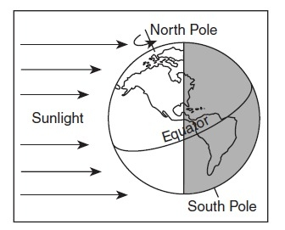
- Which part of the earth gets the most radiation? _______________________________
- Why? ___________________________________________________________________
- What season does North America is experiencing? _____________________
- What season the south hemisphere is experiencing? ___________________
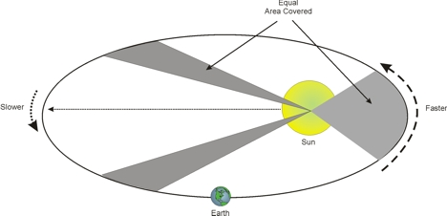
30. The diagram above shows which Kepler’s law? ___________________________
31. The distance from A-B, C-D & E-F are:
A. The time interval from A to B is twice the interval from E to F.
B. The time intervals from A to B, C to D, and E to F are all equal
C. The time intervals from A to B, C to D, and E to F combine to be equal half of a full orbit.
32. Based on the above diagram: the areas A B & C are _____________

