PRACTICE: KEPLER’S 3 LAWS ON PLANETARY MOTION
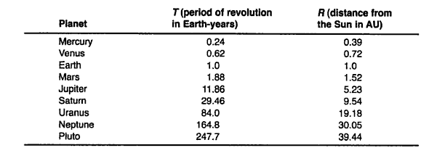
- What do you notice about the pattern of the period and distance (note, remember period = time it takes to complete a cycle)
______________________________________________________________________________________________________________________________________________________________________________________

- Which one of Kepler’s laws does the above observation apply to? Law 1, 2, 3? ________________
- Give the definition or description of the law you identified with in question 2.
_________________________________________________________________________________________________________________________________________________________________________________________________________________________________________________________________________________

- Plot the above correct data on the graph below.

PRACTICE: KEPLER’S 3 LAWS ON PLANETARY MOTION
- What do you notice about the pattern of the period and distance (note, remember period = time it takes to complete a cycle)
______________________________________________________________________________________________________________________________________________________________________________________

- Which one of Kepler’s laws does the above observation apply to? Law 1, 2, 3? ________________
- Give the definition or description of the law you identified with in question 2.
_________________________________________________________________________________________________________________________________________________________________________________________________________________________________________________________________________________

- Plot the above correct data on the graph below.

