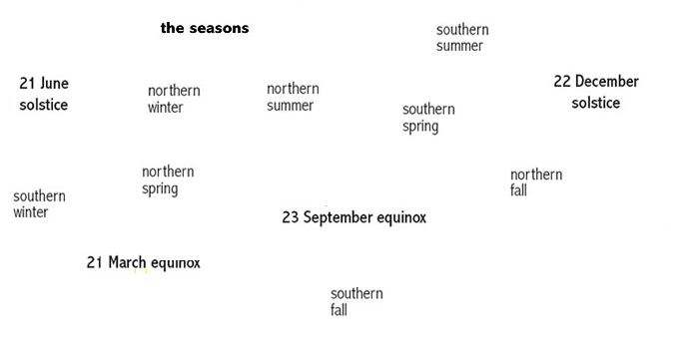

After you cut & paste the terms on the diagram, answer the following questions:
- Which diagram the north hemisphere experience summer? ____________
- Which diagram the north hemisphere experience winter? ____________
- Which diagram the north hemisphere experience spring? ____________
- Which diagram the north hemisphere experience fall? ____________
- Which diagram the north hemisphere gets most intense sunlight? _________
- Which diagram the north hemisphere gets least intense sunlight? _________
- The major factors determine the seasons? ____________________________
_________________________________________________________________
- The Earth ____________ around the sun. It takes ____________ days to complete it.
- The sun ______________ around its axis. It takes ______________ to complete it.

After you cut & paste the terms on the diagram, answer the following questions:
- Which diagram the north hemisphere experience summer? ____________
- Which diagram the north hemisphere experience winter? ____________
- Which diagram the north hemisphere experience spring? ____________
- Which diagram the north hemisphere experience fall? ____________
- Which diagram the north hemisphere gets most intense sunlight? _________
- Which diagram the north hemisphere gets least intense sunlight? _________
- The major factors determine the seasons? ____________________________
_________________________________________________________________
- The Earth ____________ around the sun. It takes ____________ days to complete it.
- The sun ______________ around its axis. It takes ______________ to complete it.

