Atmosphere Notes
- Today we will be studying the atmosphere.
  - The atmosphere is made of ____________
  - The composition of our air varies, but it is mainly _________________________
_____________________________
- The other 1% of our air is made of ______________,_____________________, ________________________________________
- There are often small amounts of other substances in our atmosphere, these include:
  - ________________________________________________________
  - _______________
  - _______________
  - ________________________
  - ________________________
  - ____________________________________________
  - __________________
  - ____________________________________________
- Humans even impact what our atmosphere is made of
- Can you think of any ways humans impact what is in our air?
  - ____________________________________
  - ____________________________________
- Ozone (O3) vs. Oxygen gas (O2)
  - Ozone is a gas that protects life on Earth from __________________________
________________________________________________________
- It is mainly found in the _____________________________, 6 – 30 miles above Earth’s surface
- How is ozone made?
  - 1.___________________________________________________________
  - 2.___________________________________________________________
  - 3.___________________________________________________________
- Structure of the Atmosphere
  - Earth’s atmosphere gradually thins to outer space..________________________
___________________________

- Pressure and Altitude
  - As the altitude ___________________, the pressure ____________________.
  - This is called an _______________________ relationship
- Pressure and Temperature
  - There are __________ layers based on temperature changes
    - _________________________ CLOSEST to Earth
    - _________________________
    - _________________________
    - _________________________ FARTHEST from Earth
- Troposphere
  - Temperature _____________________ as altitude ______________________
  - Layer of atmosphere where ____________________________________
  - Thickness - ____________________________
  - Temperature goes from ___________________________
- Stratosphere
  - From 7.5 – 12.5 miles the temperature is _____________________, then from 12.5 – 31 miles temperature __________________.
  - Temperature goes from _____________________________
    - Why does the temperature rise? Temperature rises because this is the layer where we find the ________________, and remember, ______________
_________________________________________________________
- Mesosphere
  - Temperature ______________________ as altitude _____________________
    - Thickness goes from _________________ miles
    - Temperature goes from _____________________________
- Thermosphere
  - Temperature rises in this layer because of ______________________________
- Thickness - _____________________________
- Temperature goes from ____________________________as altitude increases.
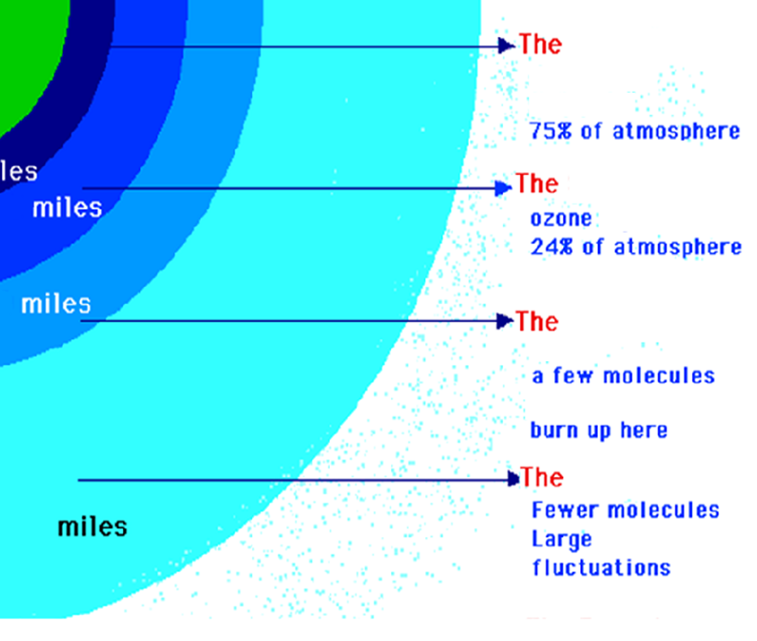
Air Masses and Weather Notes
- Air and Sun
  - For the most part, the Sun’s energy never actually ________________________
__________________________ but is lost in ____________________.
- The __________________________ is when the _______________________
________________________________ like the glass of a greenhouse. If we did not have the greenhouse effect, the Earth would ______________________
Most of the energy back into space and the _____________________________
______________________________________________________________
- The Greenhouse Effect is ____________ global warming!!
- Greenhouse Effect is_______________________!!
- Global Warming is _____________!!
- Air Masses
  - Air masses form in _________________________ and move over the Earth’s surface and _____________________________.
  - An air mass has some of the ________________________________________
________________________________________________ that it forms over.
- Two properties of Air masses are:
  - ________________________________________
  - ________________________________________
- Large Air Masses
  - Huge volumes of air that can cover ___________________________________.
  - Several types and each has ____________________________________
  - Air mass classification involves ______________________
- The first letter describes its _________________________________:
  - C for ____________________________________________ (DRY)
  - M for _________________________________________(MOIST)
- The second letter describes the ________________________________
_____________________________________________
- T for ________________________
- P for ________________________
- A for ________________________________________
- M for __________________________
- E for __________________________
- Clouds are _____________________ of weather
- For clouds to form, air must be ____________________
- _______________ types of lifting cause clouds.
  - _______________________________
  - _______________________________
  - _______________________________
- Orographic Lifting occurs when an air mass is forced from a _____________________
__________________________________________________ as it moves over
_______________________________. As the air mass ______________________
______________________________________, which can raise the humidity to 100% and create clouds and, under the right conditions, precipitation.
- Convectional Lifting
  - Earth’s surface is heated by the sun, which heats the air mass above it. _____________________________________________
_____________________________________________
- Frontal Lifting
  - ____________________________________________________________________________________________________________________________
- What are fronts?
- Air Masses Meet
  - When 2 air masses meet, __________________________________________. What happens is that they ________________________________ that is known as a _________________. Most of the weather that we think of happens along fronts.
- Cold Fronts
  - A cold front forms when a _______________________________ catches up to a _____________________________________.
  - ____________________________________________________________________________________________________________________________
  - The warm air that is pushed up ______________________________________. This reaction causes ____________________________________________ to occur along a cold front.
- Warm Fronts
  - A warm front is when a _________________________________ catches up to a______________________________________. (The opposite of a cold front.)
  - Warm air slides over the cold, dense air. _______________________________
______________________________________________________________. As the front approaches and passes it can cause _________________________ to fall. After all of this happens, the sky becomes clear and this is also when the temperature starts to rise.
- Stationary Fronts
  - A front that _______________________________ is called a stationary front. This type of front can stay in the same place for ______________.
  - When this front stays in the same place for a long time there is ______________
_____________________________________ and this leads to several inches of snow or it could even cause a _________________.
Severe Weather Notes
- What is severe weather?
  - Weather that poses a _____________________!
  - The main types of severe weather are:
    - _______________________
    - _______________________
    - _______________________
- What is a thunderstorm?
  - A storm that produces:
    - 1.__________________________
    - 2.__________________________
    - 3.___________________________________________________
    - 4.___________________________________________________
- They last about ______________________________.
- How do thunderstorms form?
  - When warm, moist ________________________________________________.
  - The air rises up to form a cumulonimbus cloud.
  - If the winds are OVER _________ mph (miles per hour), the thunderstorm is said to be a ______________________________________________!
There are two kinds of thunderstorms: ____________________ and ____________________
Cold Front Thunderstorm
- ________________ is pushed up and over _____________
- Stronger and last for several hours
- Can have _______________________ and ____________
Warm Air Thunderstorms
- Doesn’t involve cold air at all!
- Caused by ___________________________________________________________________.
- Usually occur in _______________________________________________________.
Most Thunderstorms occur in three stage:
- ________________________:

- ________________________:

- _______________________:

Lightening
- What causes lightening?

- How does lightning form?
  - __________________and _______________________of wind and rain cause different parts of a cloud to become__________________________________.
  - ______ charge at TOP of cloud
  - ______ charge at BOTTOM of cloud
- How far away is lightning?
  - _______________________ between a lightning flash and thunder means the storm is _____________ away.
  - Speed of light : 186,000 miles/second or 300,000 km/second
  - Speed of sound : 1100 ft/second (330 m/ second)
- Struck by Lightning!!!
  - The odds of becoming a lightning victim in the U.S. in any one year is __________________________________
  - The odds of being struck in your lifetime is __________________________
- The Safest Place?
  - ____________________________________ is the leading cause of lightning injuries _________________________________
  - Standing under a tall ____________ is one of the most dangerous places to take shelter _________________________
- Thunder
  - Caused by the ______________________________________________of the __________________________________________________________
Tornado definition: __________________________________________________________
__________________________________________________________________________
The center of a tornado is characterized by:

- How does a tornado form?
  - Tornado – a rotating column of air
    - 1. __________________________________ causes air to rotate
    - 2. The rotating ___________________ of air is _______________ by ________________________
    - 3. The column of air _________________________________________
- Tornadoes are usually associated with _________________________________
- How are tornadoes classified?
  - ______________________________________________________________
F Number | Wind Speed | Damage
Tornado Warning system
- Watch: _______________________________________________________________

- Warning: ______________________________________________________________

- Hurricanes: ____________________________________________________________
  - A ______________________area of ________________________________
___________________________________________
- Wind speeds must be greater than __________________
- Usually given _______________________________ for convenience
- ______________________________________________________________
- Pushed by the ___________________________________________________
Parts of a hurricane: Eye: ____________________________________________________
Eyewall: _________________________________________________________________
- 5 Things a hurricane needs to form
  - 1. Warm ocean water ( 80°F +) – provides the energy and causes evaporation for humid clouds
  - 2. Winds coming together force air upward
  - 3. Winds flow outward above the storm, allowing air below to rise
  - 4. Humid air rising makes the clouds of the storm
  - 5. Light winds outside the hurricane steer it and let it grow
- Progression to a Hurricane
- ______________ ______________ ________________ ________________

- Tropical Disturbance:

- Tropical Depression:

- Tropical Storm

- Hurricane:
- _______________________________________is used to measure a hurricane’s intensity
- Most dangerous part of hurricanes
  - ______________________________-like what happened with Hurricane Katrina
  - Storm Surge: ______________________________________________________
Weather Maps Notes
- Types of Maps - There are 5 basic types of maps:
    - 1.____________________ 2.______________________
    - 3.____________________ 4.______________________
    - 5.____________________________
- Pressure Maps - Tells the __________________________
  - Gives the locations of ___________________ areas and _______________________ areas
- Low Pressure and Bad Weather
  - Air warmed by the sun on the Earth’s surface can __________________ than cool air. As the warm moist air ______________, it begins to __________. Eventually, the air reaches a level where it is too cool to continue to hold its moisture. At this point the moisture condenses out to become ____________. The clouds release their water as ____________________________.
- High Pressure and Clear Weather
  - High pressure areas are produced by cooler, heavier, sinking air. This air contains _________________________________________________. In the summer, high pressure usually means sustained sunshine, few clouds, low winds, high temperatures, and dry weather. In winter, the lack of cloud cover can cause the temperatures to be _______________________, since the lack of clouds allows ________ from the Earth to _______________________________________.
- Aviation Maps
  - Tells information necessary for safe ___________________________
    - ________________________ ______________________
    - ________________________ ______________________
    - ________________________
- Temperature Maps
  - Shows temperature either in ____________________________ format or with the actual numbers
- Streamline Maps - __________________________

- Station Model Maps
  - Shows the weather conditions at a particular _____________________
(a place where weather is measured and recorded)
- Several conditions are measured:
- ___________________ ______________________
- ___________________ ______________________
- ___________________ ______________________
- Symbols are used
- What is Humidity?
  - Humidity refers to the amount of ___________________(water vapor) in the surrounding air.
- Relative Humidity
  - __________________ of the amount of moisture in the air compared to the amount of moisture the air can hold at that temperature and pressure
    - Expressed as a ___________________
- We are very sensitive to humidity. Sweating keeps our body cool and maintains its current temperature.
- How is Relative Humidity Measured?
  - __________________________________
  - It consists of two identical mercury thermometers
    - Evaporating water from the wick absorbs the heat from the thermometer bulb, causing the thermometer reading to drop.
- Find the difference between the DRY bulb and the WET bulb on the two thermometers ◊ Use the__________________________
- Where the DRY bulb temperature and the DIFFERENCE between the two thermometers intersects…is your relative humidity.
- Why care about Relative Humidity?
  - If we can’t sweat…we could ______________________________!!!
- Dew Point
  - The temperature that air would need to ________________________
- Dew Point is determined the ___________________________________ that Relative Humidity is calculated…a __________________________________
- You just use a DIFFERENT chart…the __________________________...DUH!!

